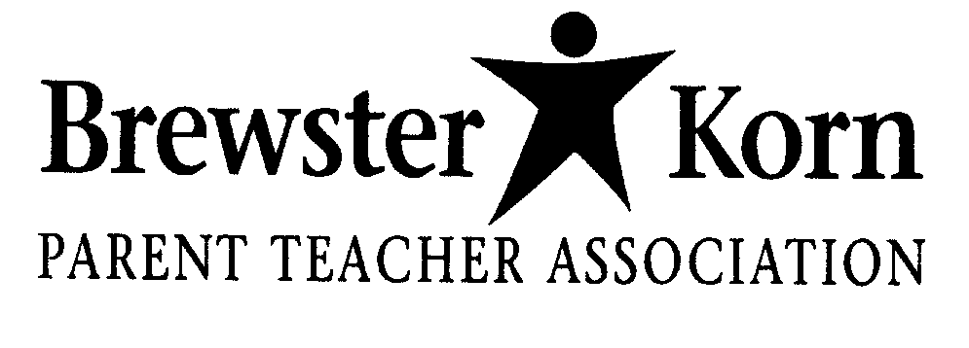

Dear Parent/Guardian:

We are very excited! Your child has been learning about the scientific method and having fun with it during library time! We hope that your child would be interested in researching a question, developing a science fair project and presenting it at the Brewster/Korn Science Fair Night, sponsored by the BKPTA, on February 27, 2014. Snow date to be determined.

Please discuss this with your child and return the permission slip by Friday, December 13, 2013.

All students who turn in permission slips by December 13th will receive a packet of information containing a general timeline, detailed worksheets to help them plan out the details of the experiment, and information to aid your student in putting together their poster presentation for the science fair. Specific rules for the science fair will also be included.

Please don’t hesitate to call or email with any questions. Thank you very much in advance for your support!

Sincerely,

Jenny Lussier, Oanh Stephan,
Library Media Specialist, Korn School Science Fair Coordinator
(jlussier@rsd13.org) (PHUONGOANH.STEPHAN@bms.com) 860-349-7210

- My child will be participating in the Korn Science Fair night on February 27, 2014
Name of Child

Teacher Grade_______
Parent(s) ______________________________________________________________

Email

